

**DIGITAL ASSIGNMENT 2**

**NAME: AYUSH SHARMA**

**REGISTER NUMBER: 21BDS0058**

**COURSE CODE: BCSE302P**

**COURSE NAME: DATABASE SYSTEM LAB**

# Aim: To understand different types of function in SQL Consider the following schema (used in EX2):

1. **Display the employee names whose bdate is on or before 1978. SQL Command:**

Select First_Name, Mid_Name, Last_Name, Birthday from Employee where extract(Year from Birthday) <1978;

# Screenshot:

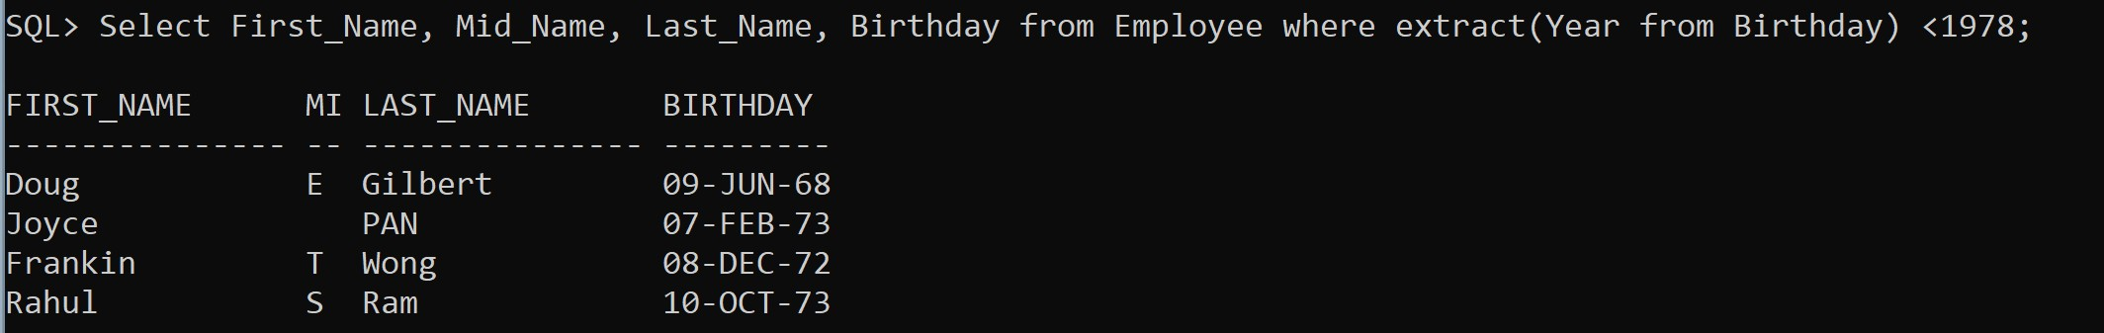

1. **Display all the department names in upper case and lower case. SQL Command:**

Select lower(Department_Name) from Department; Select upper(Department_Name) from Department;

# Screenshot:

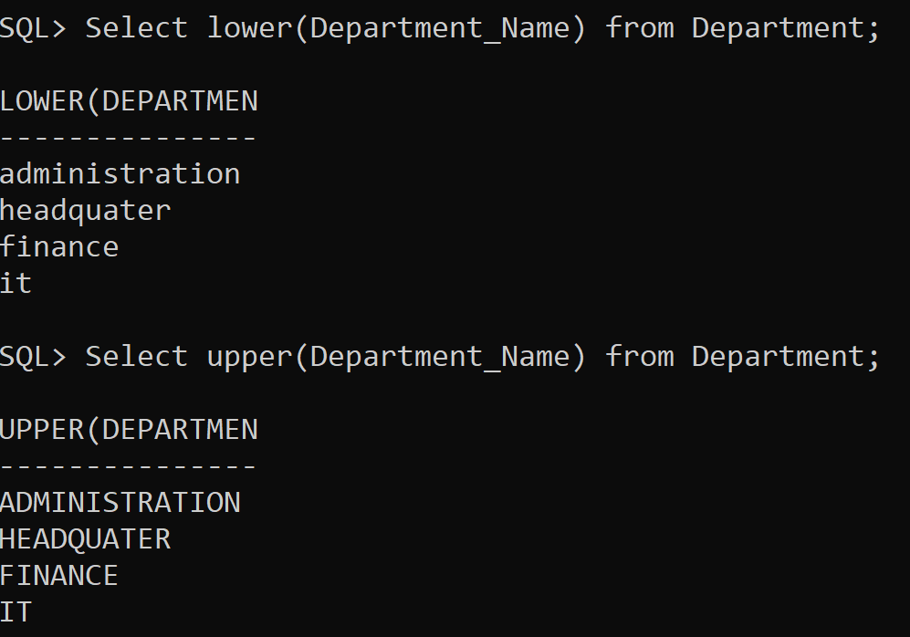

1. **Display the first four characters and last four of the department names using substring function.**

# SQL Command:

select Department_Name, substr(Department_Name, 0,4) from Department;

select Department_Name, substr(Department_Name, length(Department_Name)-4) from Department;

# Screenshot:

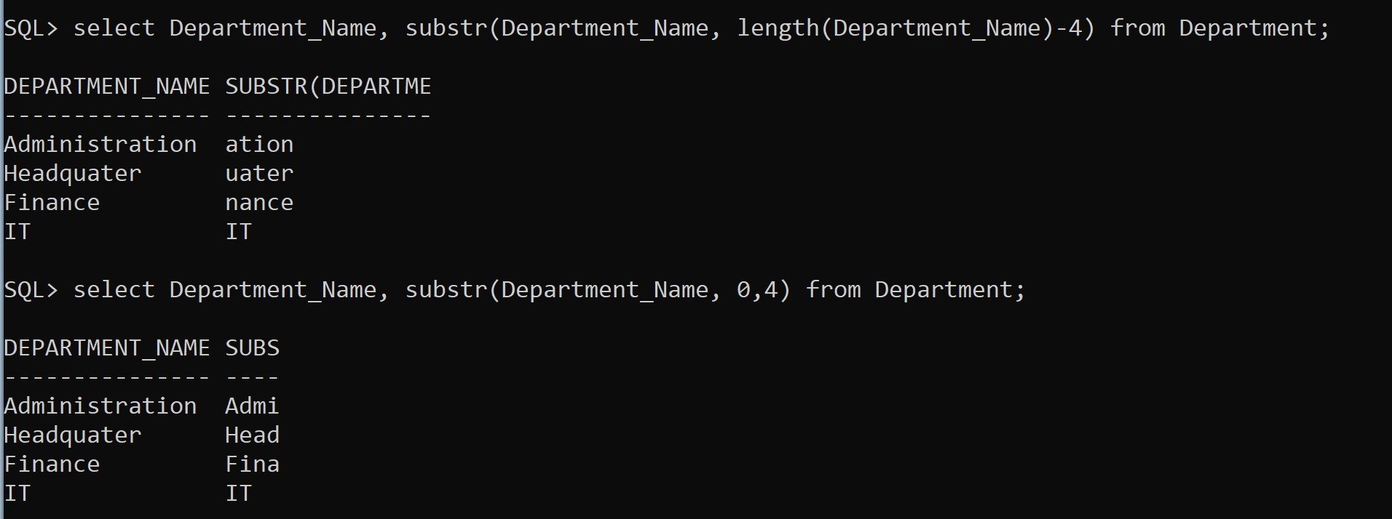

1. **Display the substring of the Address (starting from 5th position to 11 th position) of all employees.**

# SQL Command:

Select Address, substr(Address, 5,6) from Employee;

# Screenshot:

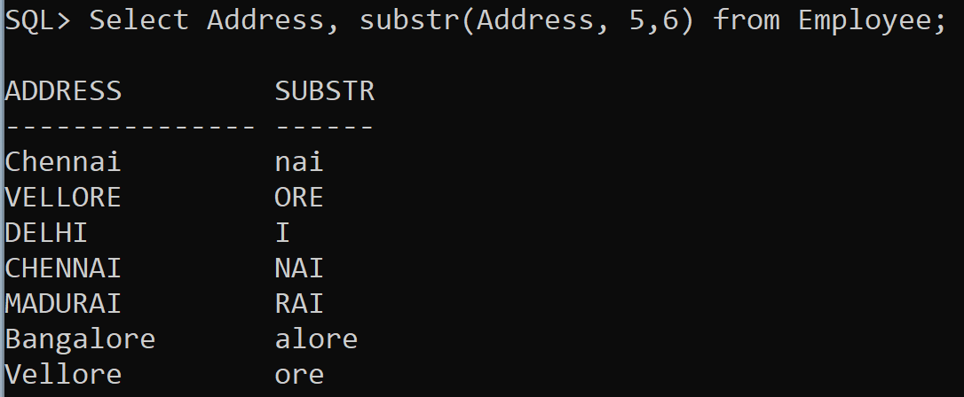

1. **Display the Mgrstartdate on adding three months to it. SQL Command:**

Select Manage_Start_Date, add_months(Manage_Start_Date,3) from Department;

# Screenshot:

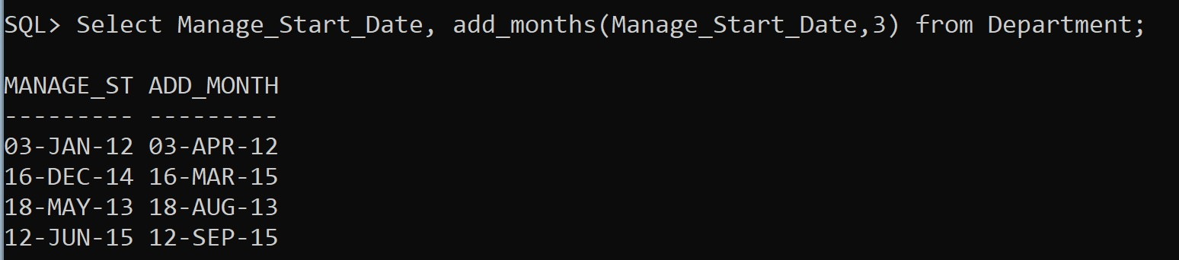

1. **Display the age of all the employees rounded to two digits. SQL Command:**

Select First_Name, Birthday, round( months_between( '1-JUN- 2023’, Birthday) /12) as Age from Employee;

# Screenshot:

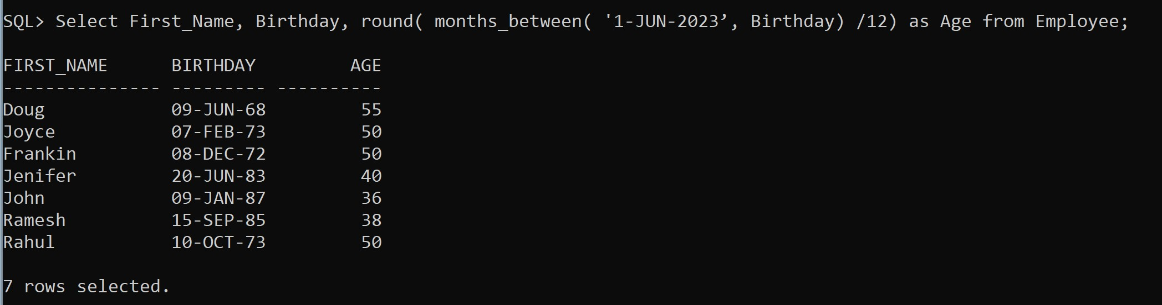

1. **Display the bdate of all employees in the format ‘DDthMonthYYYY’. SQL Command:**

select Birthday, extract(Day from Birthday) as Day, extract(Month from Birthday) as Month, extract(Year from Birthday) as Year from Employee;

# Screenshot:

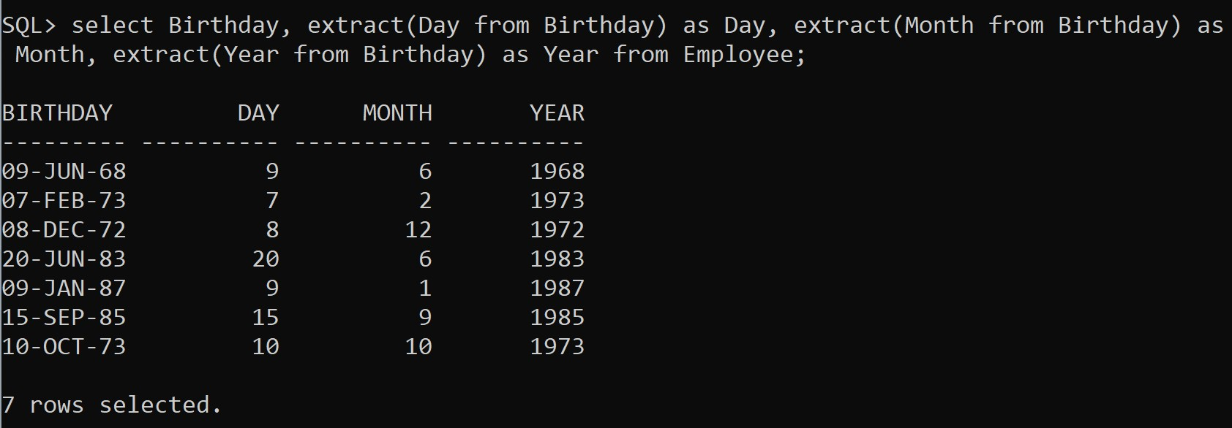

1. **Find the last day and next day of the month in which each manager has joined.**

# SQL Command:

Select Manage_Start_Date, last_day(Manage_Start_Date) as Last_Day , Manage_Start_Date + 1 as Next_Day from Department;

# Screenshot:

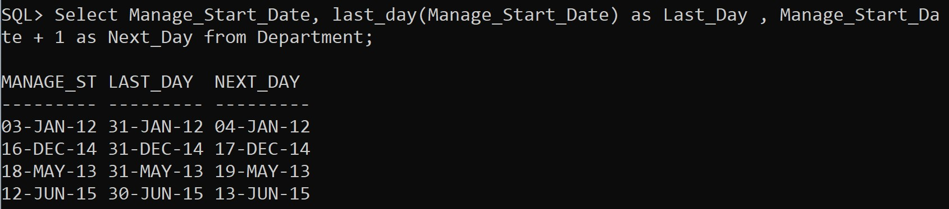

1. **Print a substring from the string ‘Harini’. SQL Command:**

Select substr('Harini', 0,2) from dual;

# Screenshot:

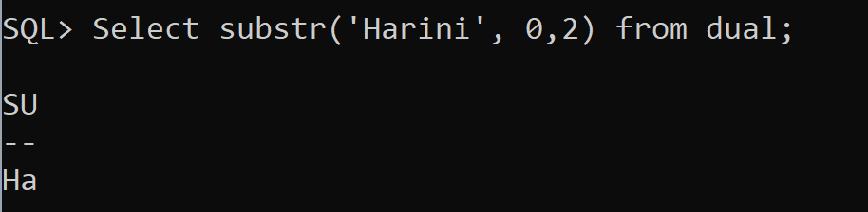

1. **Replace the string ‘ni’ from ‘Harini’ by ‘sh’.**

# SQL Command:

Select replace('Harini' , 'ni', 'sh') from dual;

# Screenshot:

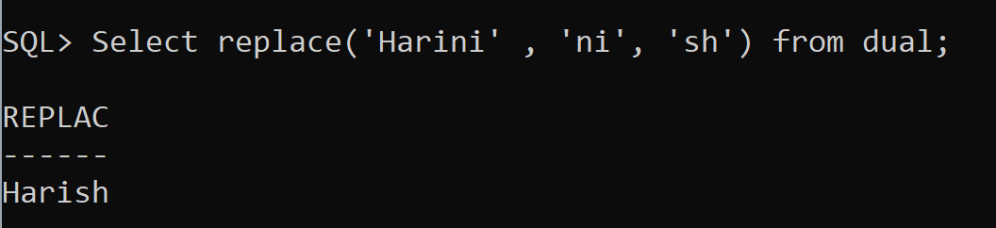

1. **Print the length of all the department names.**

# SQL Command:

Select Department_Name, length(Department_Name) as Length from Department;

# Screenshot:

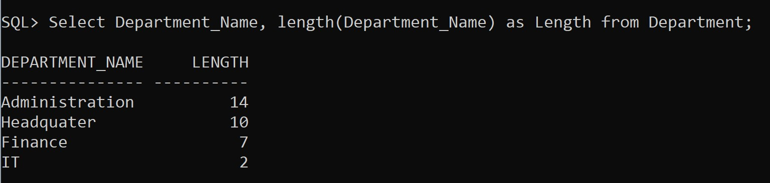

1. **Display the date after 10 months from current date.**

# SQL Command:

Select CURRENT_DATE as Today, add_months(CURRENT_DATE, 10) from dual;

# Screenshot:

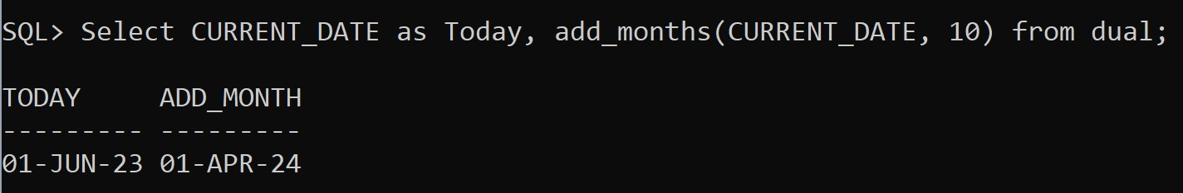

1. **Display the next occurrence of Friday in this month.**

# SQL Command:

Select CURRENT_DATE, next_day(CURRENT_DATE, 'FRI') as Next from dual;

# Screenshot:

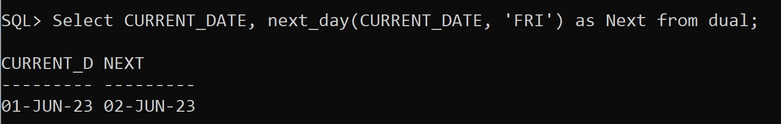

1. **Display the project location padded with **** on left side.**

# SQL Command:

Select Department_Name, concat('****',Department_Name) as CONCAT from Department;

# Screenshot:

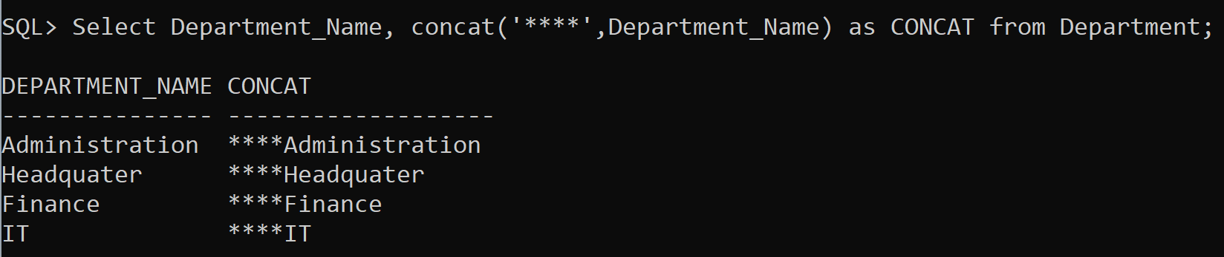

1. **Display the day of next Saturday.**

# SQL Command:

Select CURRENT_DATE, next_day(CURRENT_DATE, 'SAT') as SAT_DATE , extract(Day from next_day(CURRENT_DATE, 'SAT')) as SATURDAY from dual;

# Screenshot:

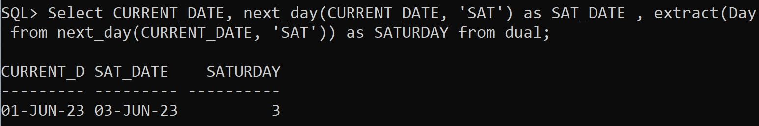

1. **Display the last date of Feb 2022 SQL Command:**

Select last_day('01-FEB-2022') as LAST_DAY from dual;

# Screenshot:

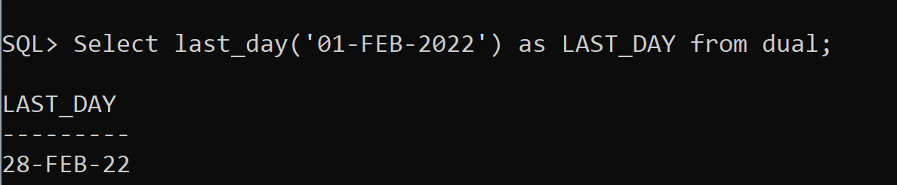

1. **Count the number of days present between today and Sunday.**

# SQL Command:

Select CURRENT_DATE, Next_Day(CURRENT_DATE, 'SUN') as NXT_SUN , Next_Day(CURRENT_DATE, 'SUN') - CURRENT_DATE as

DAYS from dual;

# Screenshot:

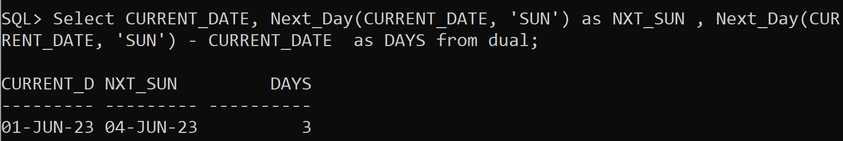

1. **Display all the employees whose experience is greater than 14 yrs.**

# SQL Command:

Select Manage_Start_Date, First_Name from Employee natural join Department where (months_between(sysdate, Manage_Start_Date) /12)>14;

# Screenshot:

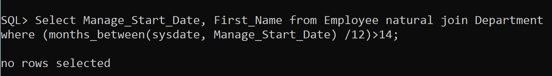

**Group Functions**

# Find the total salary of all employees SQL Command:

select sum(Salary) from Employee;

# Screenshot:

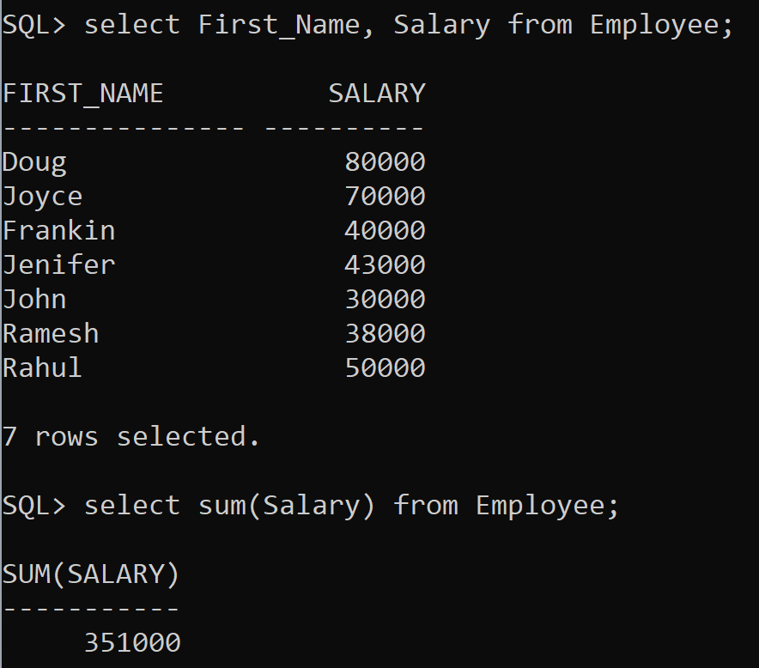

1. **Display the min, max salary given to employees SQL Command:**

select min(Salary) from Employee; select max(Salary) from Employee;

# Screenshot:

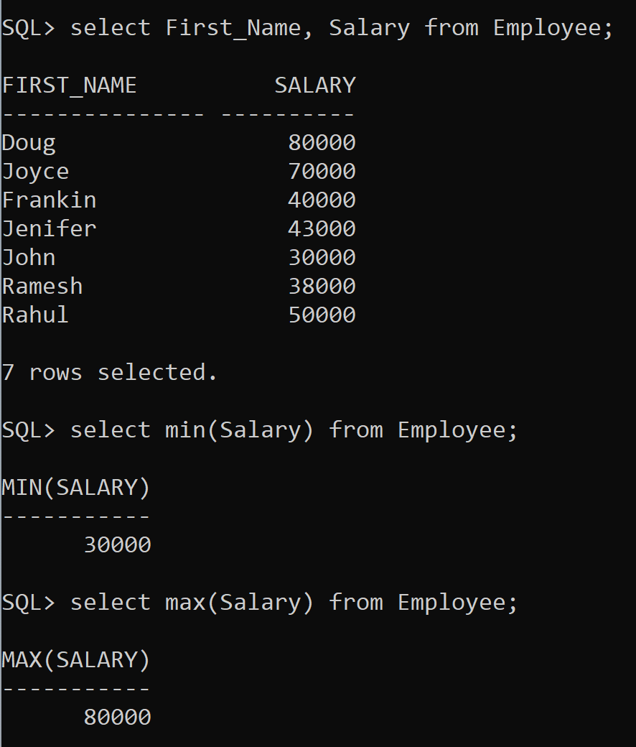

1. **Display the avg salary of all employees SQL Command:**

select avg(Salary) from Employee;

# Screenshot:

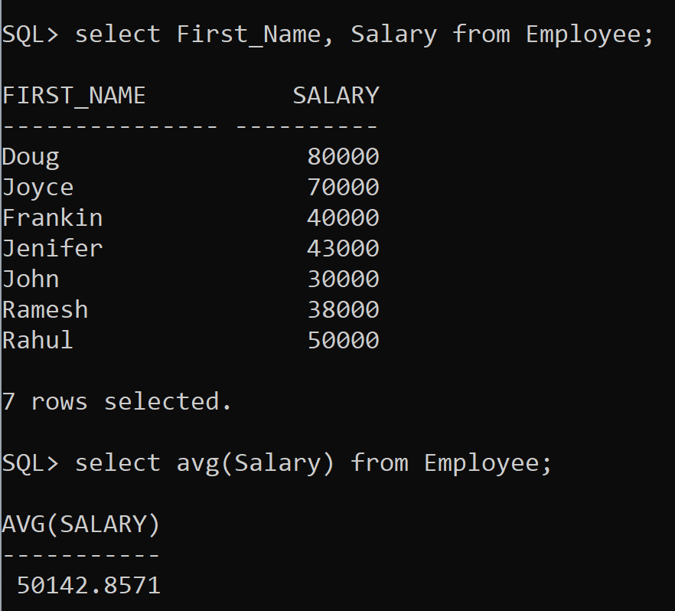

1. **Display the total number of employees SQL Command:**

select count(*) as Employees from Employee;

# Screenshot:

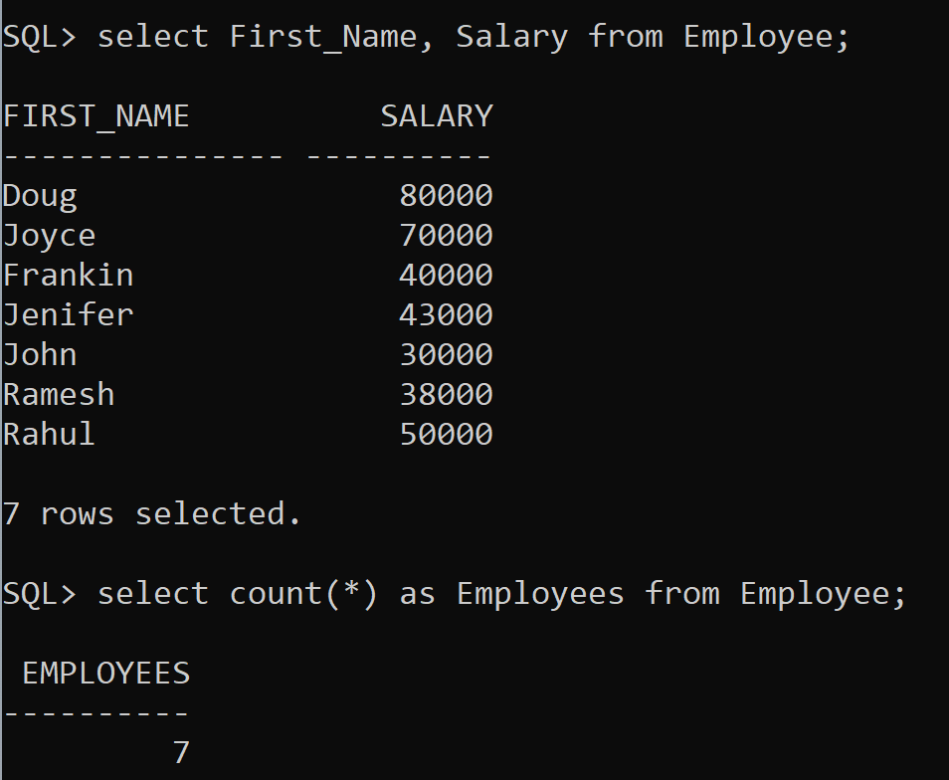

1. **How many different departments are there in the ‘employee’ table SQL Command:**

select count(distinct Department_Number) as No_Dep from Employee;

# Screenshot:

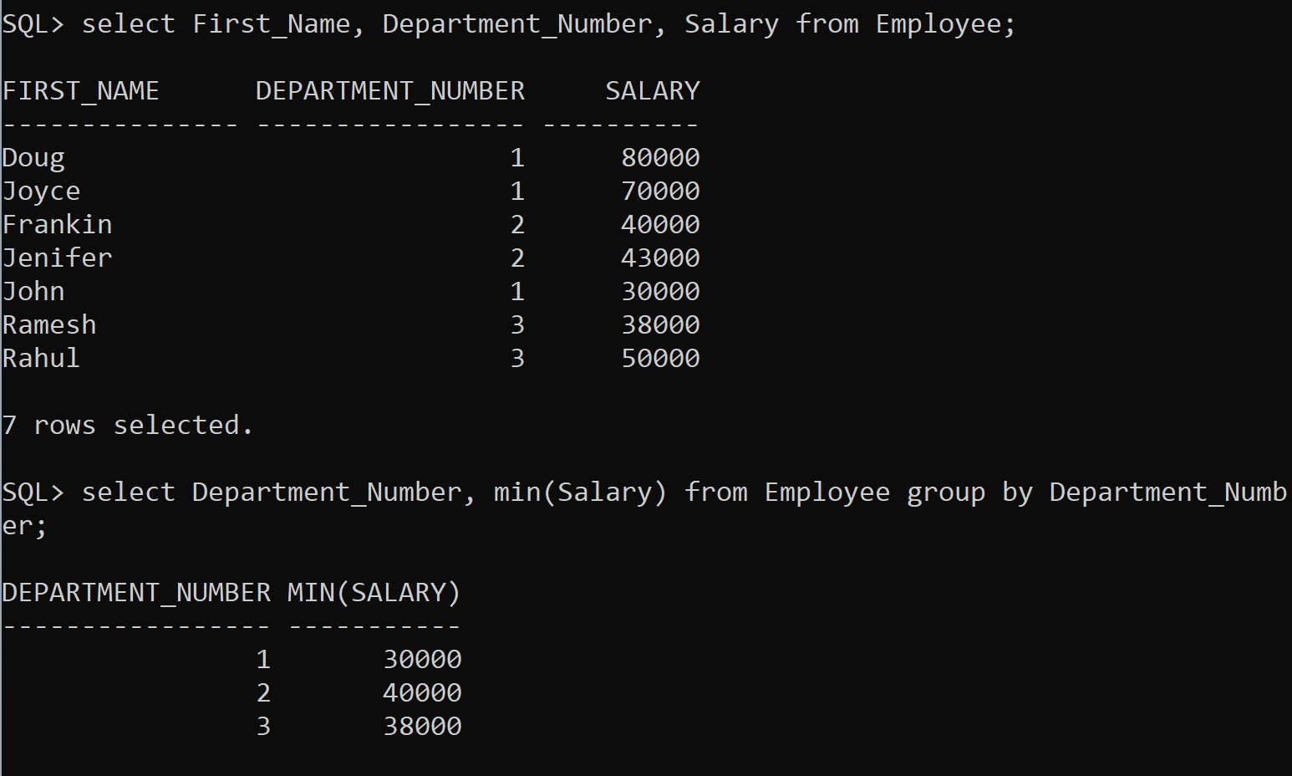

1. **For each department display the minimum and maximum employee salaries SQL Command:**

select Department_Number, min(Salary) from Employee group by Department_Number;

select Department_Number, max(Salary) from Employee group by Department_Number;

# Screenshot:

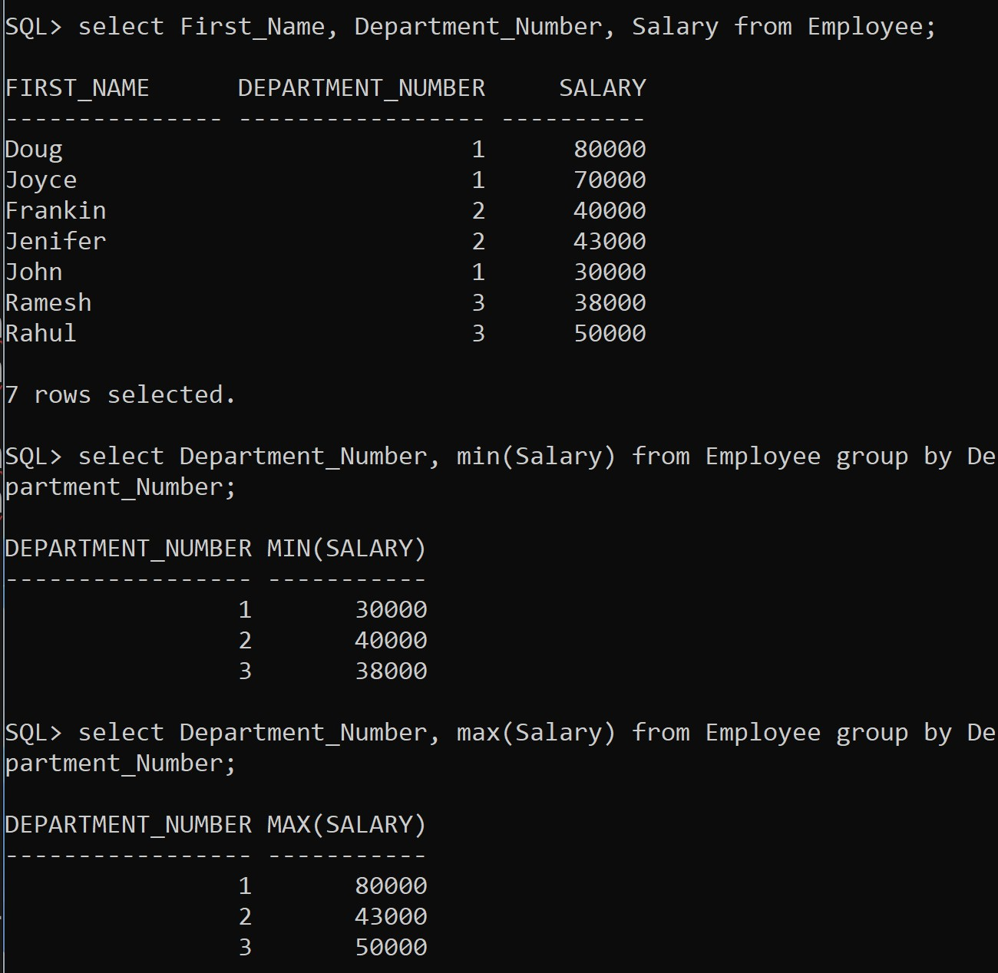

1. **Print the average annual salary.**

# SQL Command:

select avg(Salary)*12 as Avg_Annual from Employee;

# Screenshot:

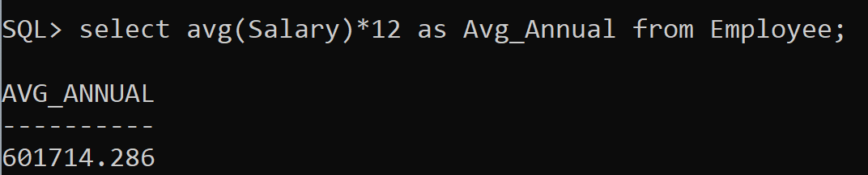

1. **Count the number of employees over 30 age.**

# SQL Command:

select count(*) from Employee where round(months_between(sysdate, Birthday)/12)>30;

# Screenshot:

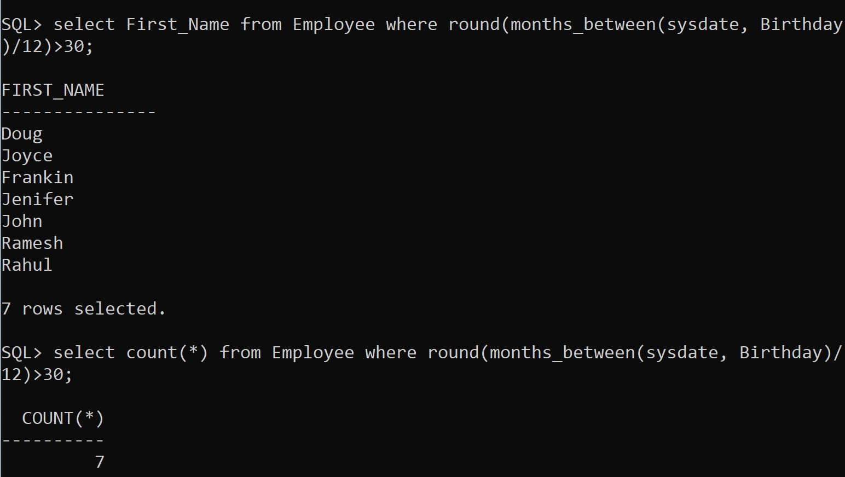

1. **Print the Department name and average salary of each department.**

# SQL Command:

select avg(Salary) as Avg_Salary, Department_Number from Department natural join Employee group by Department_Number;

# Screenshot:

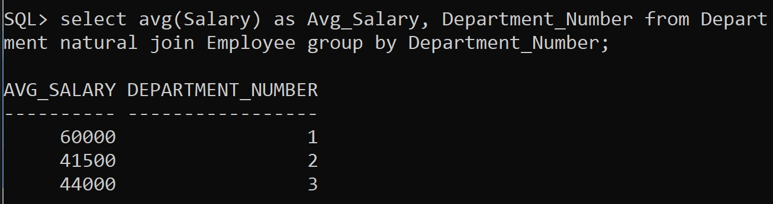

1. **Display the department name which contains more than 2 employees.**

# SQL Command:

Select Department_Number, Department_Name,count(*) from Department where exists (select SSN_Number from Employee where Department_Number = Department.Department_Number having count(*)>2 );

# Screenshot:

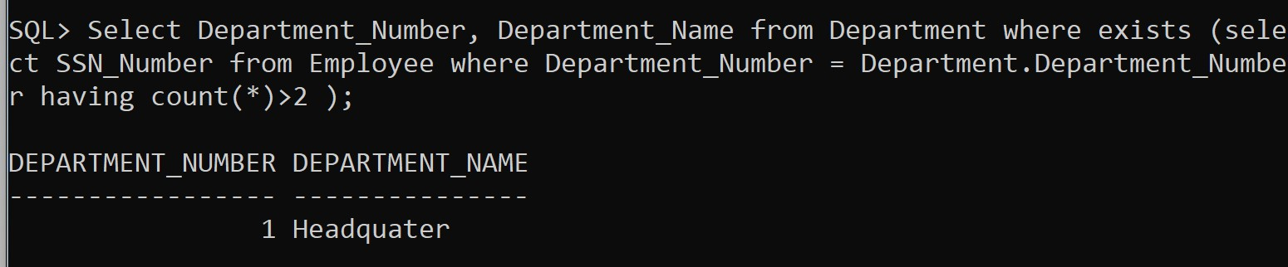

1. **Calculate the average salary of employees by department and age SQL Command:**

Select Department_Number, avg(Salary) from (Employee natural join Department) group by Department_Number;

Select avg(Salary), round(months_between(sysdate, Birthday)/12) as Age from (Employee natural join Department) group by round(months_between(sysdate, Birthday)/12) order by Age;

# Screenshot:

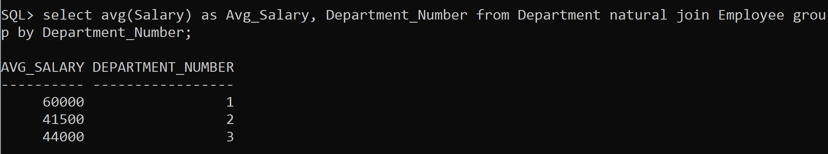

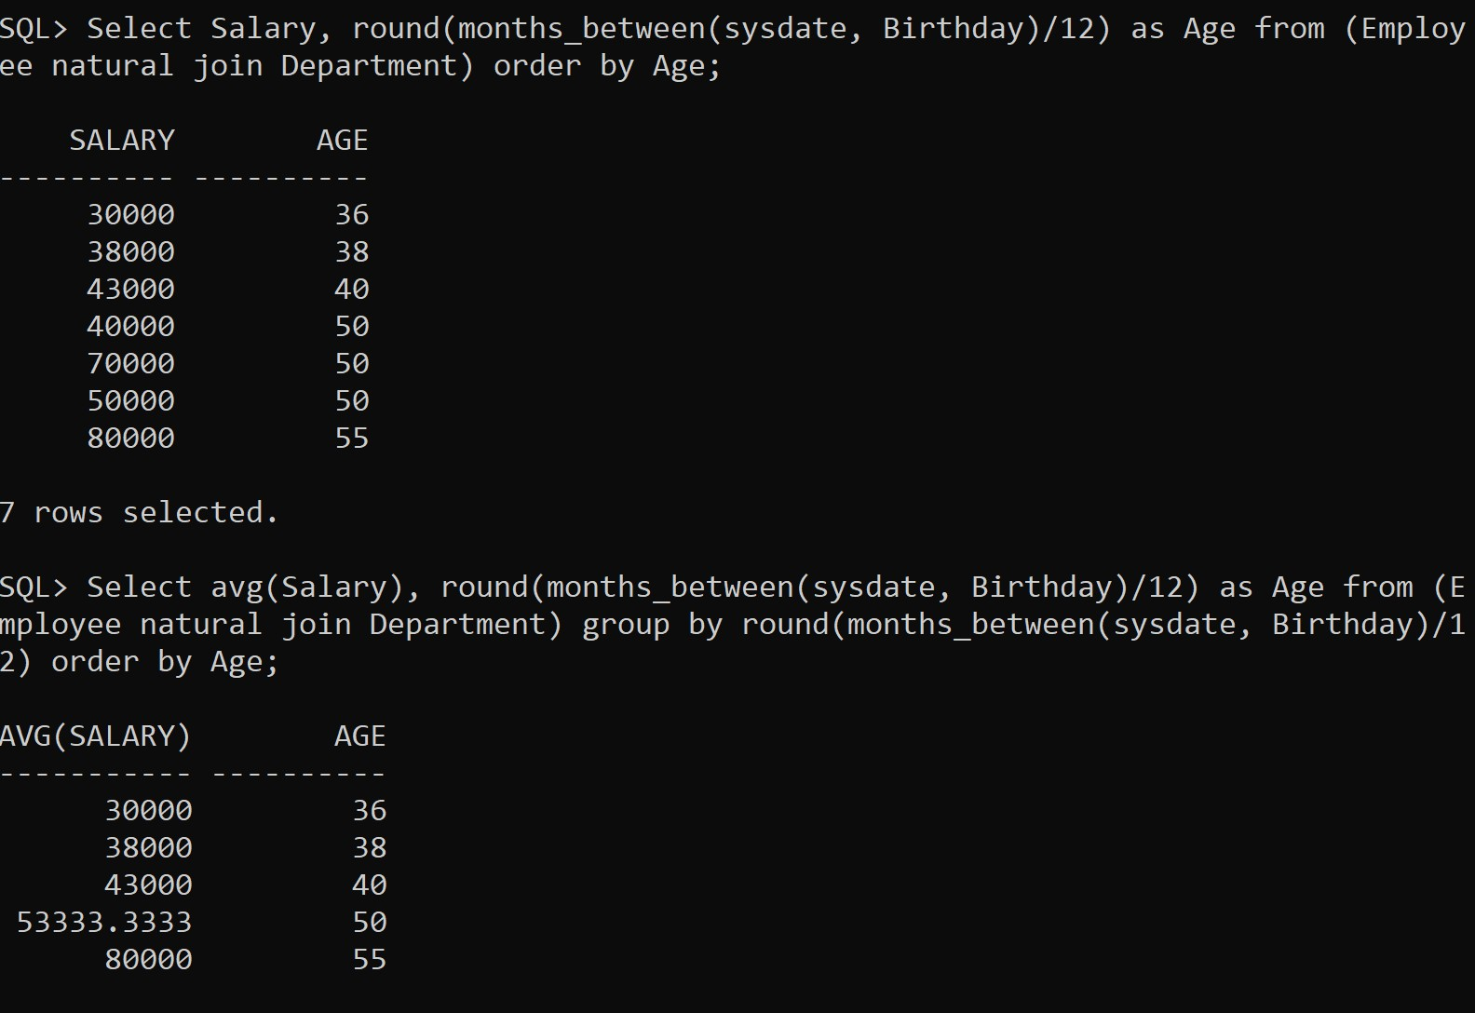

1. **Count separately the number of employees in the finance and administration department.**

# SQL Command:

Select First_Name from (Employee natural join Department) where Department_Name = 'Finance';

Select count(*) from (Employee natural join Department) where Department_Name = 'Finance';

Select First_Name from (Employee natural join Department) where Department_Name = 'Administration';

Select count(*) from (Employee natural join Department) where Department_Name = 'Administration';

# Screenshot:

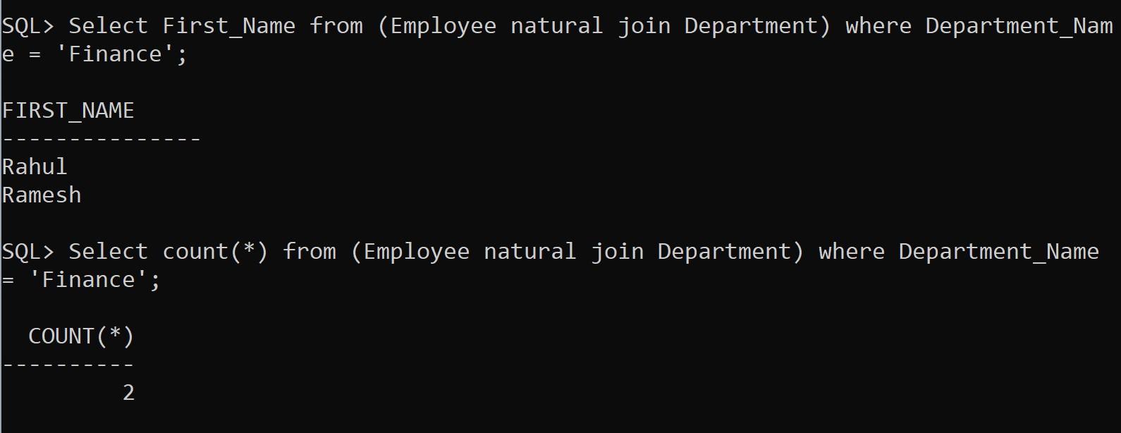

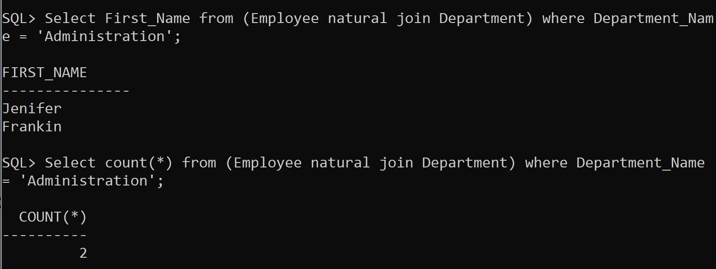

1. **List out the employees based on their seniority.**

# SQL Command:

Select First_Name, round(months_between(sysdate, Manage_Start_Date)) as Experience, Department_Name from (Employee natural join Department) where Department.Manager_SSN = Employee.SSN_Number order by Experience;

# Screenshot:

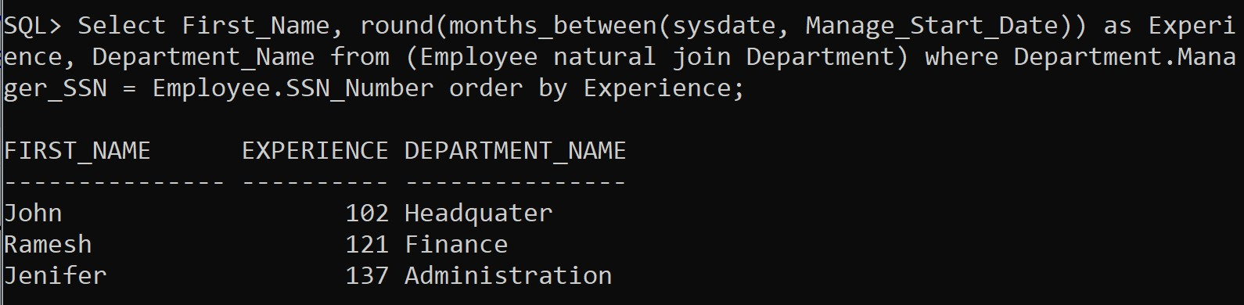

1. **Display the total number of employees who are assigned to a department.**

# SQL Command:

Select Department_Number, count(*) from (Department natural join Employee) group by Department_Number;

# Screenshot:

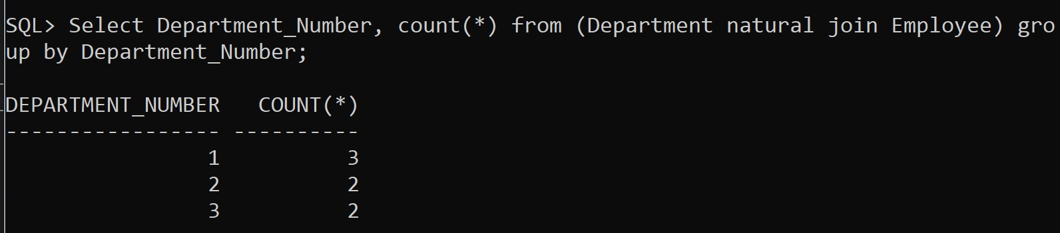

1. **Display only department numbers that are paying a total salary of more than 30000 to its employees**

# SQL Command:

Select Department_Number, sum(Salary) from Employee group by Department_Number having sum(Salary)>30000;

# Screenshot:

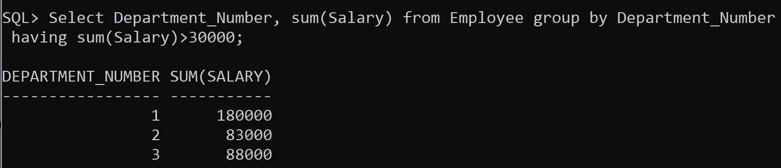

1. **Display all the employees working under the department 1.**

# SQL Command:

Select First_Name, Department_Number from Employee where Department_Number = 1;1

# Screenshot:

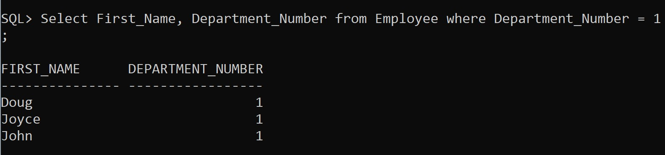

1. **Display employees whose salary is between 5000 and 10000 in department no 1.**

# SQL Command:

Select First_Name, Department_Number, Salary from Employee where Department_Number = 1 and salary > 5000 and salary

<10000;

# Screenshot:

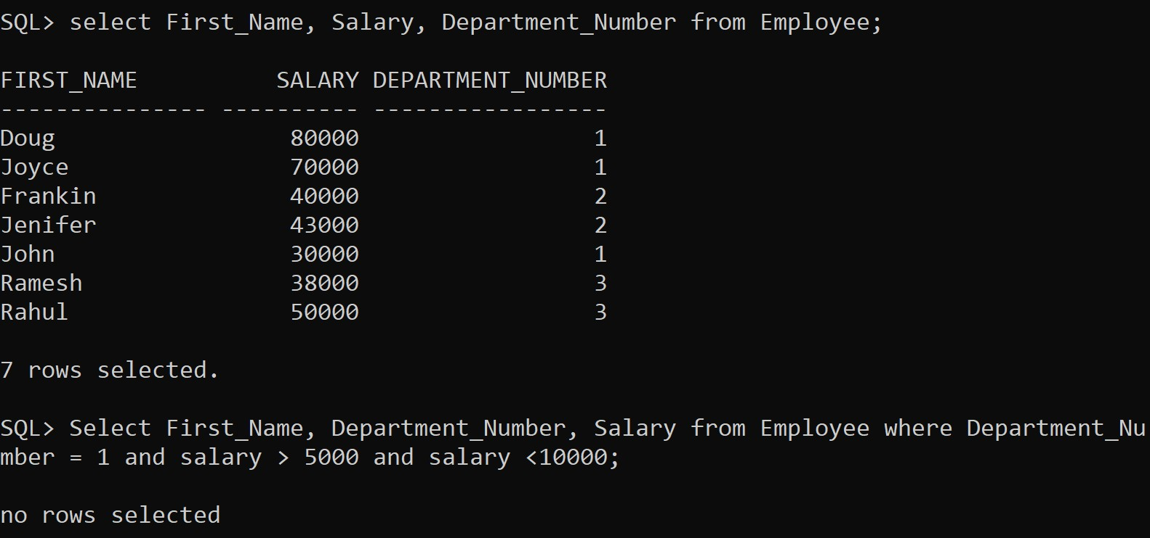

**SUB QUERY AND VIEW IN SQL**

# Aim: To understand different types of function in SQL Consider the schema (used in EX2):

1. **Find the employee who is getting highest salary in the department headquarters.**

# SQL Command:

Select First_Name,Department_Name, Salary from (Employee natural join Department) where Salary = (Select max(Salary) from Employee) and Department_Name = 'Headquater';

# Screenshot:

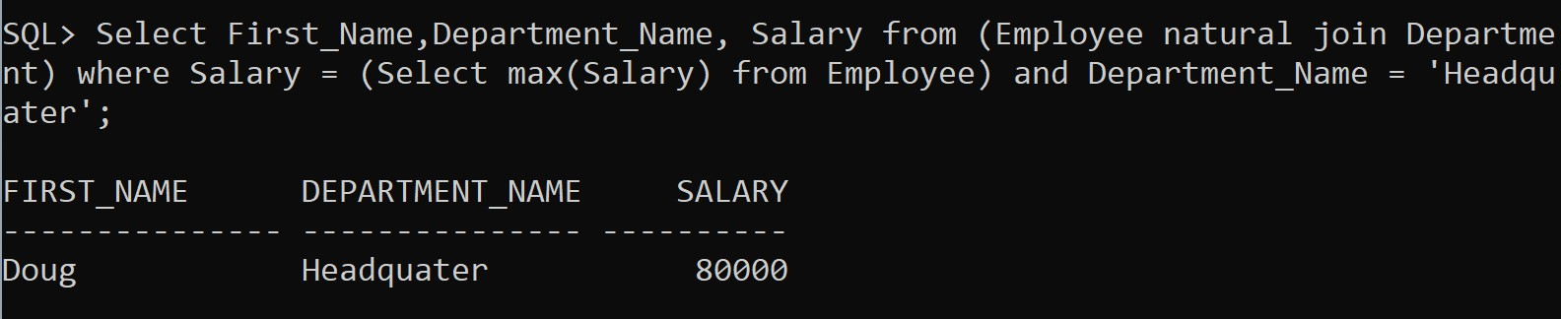

1. **Find the employees who earn the same salary as the minimum salary for each Department.**

# SQL Command:

Select First_Name, Department_Name,Department_Number, Salary from (Employee natural join Department) where Salary in(Select min(Salary) from Employee group by Department_Number);

# Screenshot:

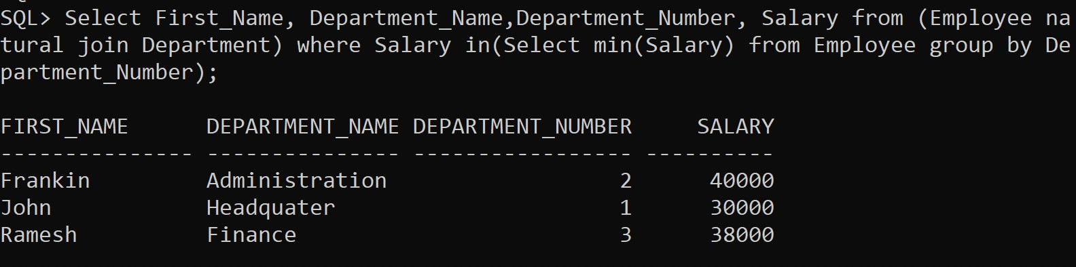

1. **Find the employee whose salary is greater than average salary of department 2.**

# SQL Command:

Select First_Name, Department_Name, Department_Number, Salary from (Employee natural join Department) where Salary

> (Select avg(Salary) from Employee where Department_Number

= 2);

# Screenshot:

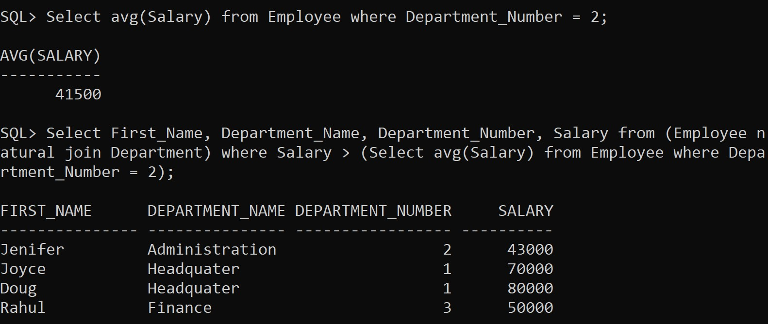

1. **List out all the department names with their individual employee’s strength. SQL Command:**

Select Department_Name, Department_Number, count(*) from (Employee natural join Department) group by Department_Number, Department_Name;

# Screenshot:

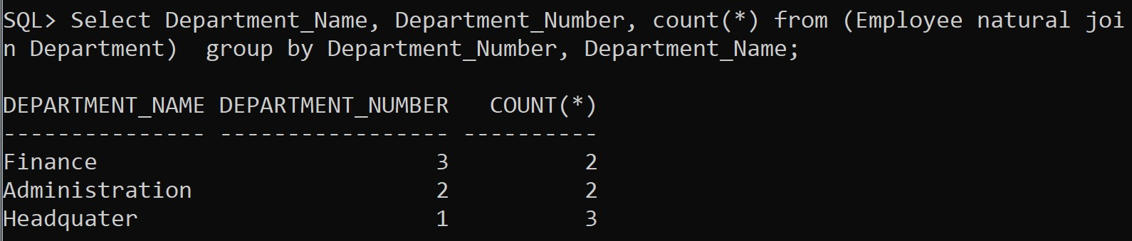

1. **Find out the department name having highest employee strength. SQL Command:**

Select Department_Name, Department_Number from Department where Department_Number in (Select Department_Number from Employee group by Department_Number having count(*) in (select max(Employees) from (Select count(*) Employees from Employee group by Department_Number)));

# Screenshot:

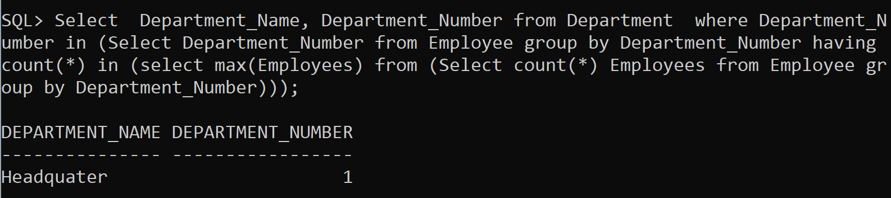

1. **List out all the departments and average salary drawn by their employees. SQL Command:**

Select Department_Name, avg(Salary) from (Employee natural join Department) group by Department_Name, Department_Number;

# Screenshot:

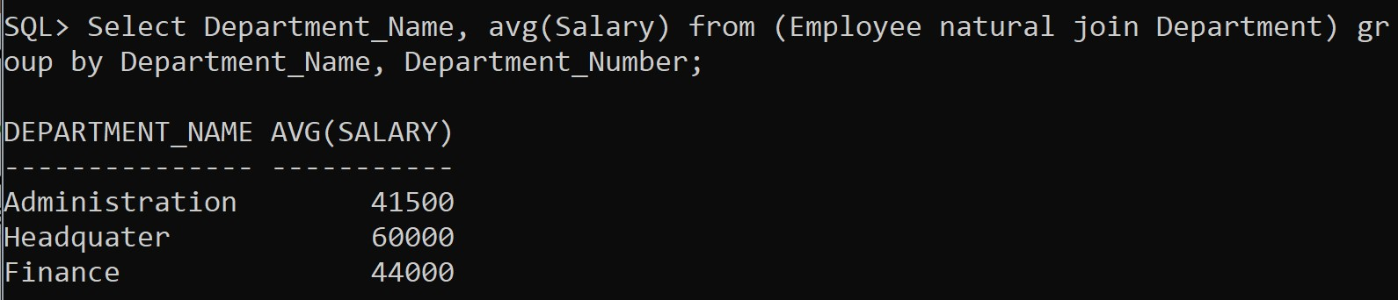

1. **Find average salary for each department. SQL Command:**

Select Department_Name, avg(Salary) from (Employee natural join Department) group by Department_Name, Department_Number;

# Screenshot:



1. **Create a view to display the employee details who is working in Administration department.**

# SQL Command:

Create view Administration_Emp as Select * from Employee where Department_Number = (Select Department_Number from Department where Department_Name = 'Administration');

Select * from Administration_Emp;

# Screenshot:

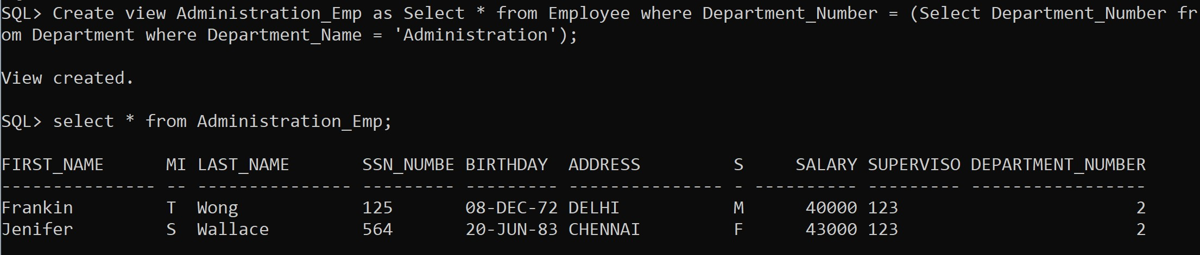

1. **Create a logical table to store employee details who is getting salary more than 10000.**

# SQL Command:

Create view Salary10000 as Select * from Employee where salary>10000;

select * from Salary10000;

# Screenshot:

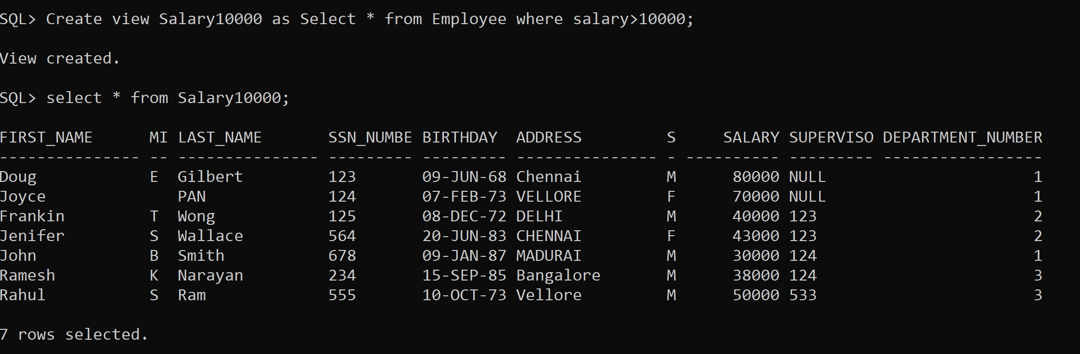

1. **Create a view to display the employee details who is working in finance or administration department.**

# SQL Command:

Create view Emp_Fin_Adm as Select * from Employee where Department_Number in (Select Department_Number from Department where Department_Name = 'Finance' or Department_Name = 'Administration');

select * from Emp_Fin_Adm;

# Screenshot:

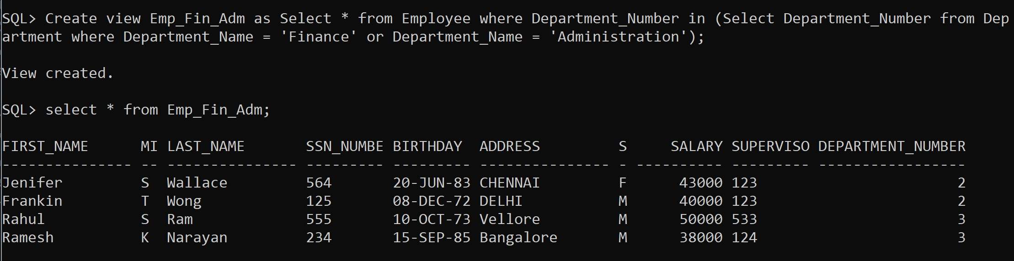

1. **Create a view to display all employees whose salary is greater than “Jennifer”.**

# SQL Command:

Create view SalaryJenifer as Select * from Employee where Salary > (Select Salary from Employee where First_Name = 'Jenifer');

select * from SalaryJenifer;

# Screenshot:

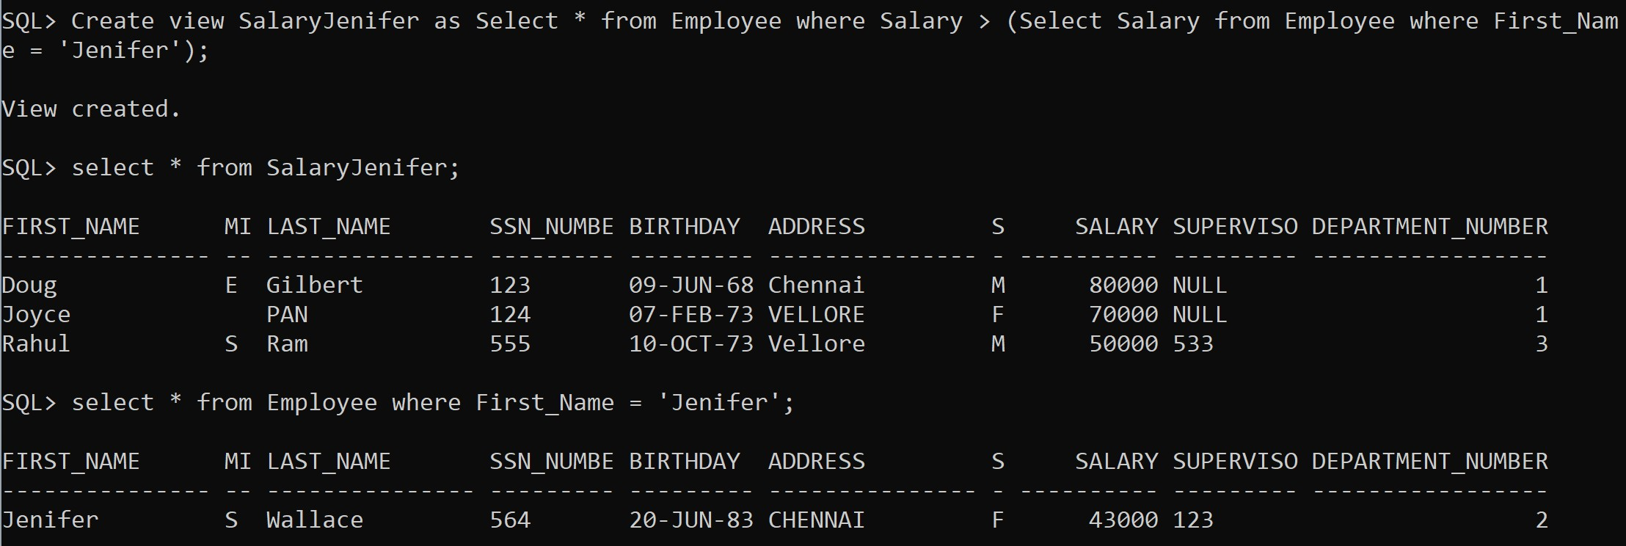

1. **Create a view to display all employees in descending order of employee first name**

# SQL Command:

Create view First_Name_Desc as select * from Employee order by First_Name desc;

select * from First_Name_Desc;

# Screenshot:

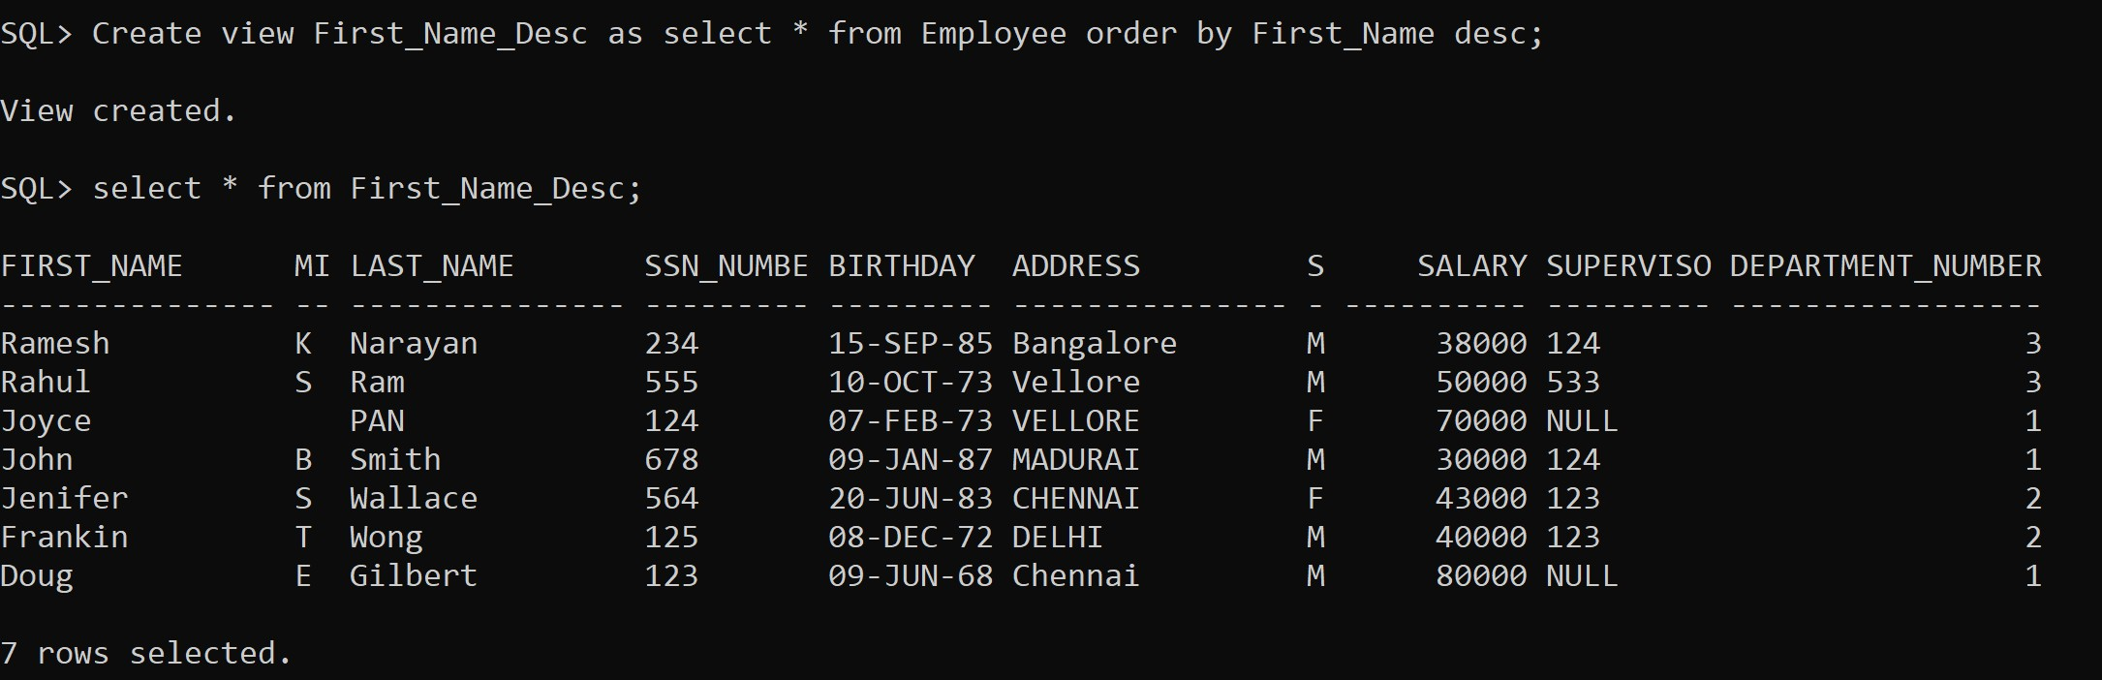

1. **Create a view to display all employees whose salary is greater than the average salary of the employees.**

# SQL Command:

Create view Salary_Greater_Avg as select * from Employee where Salary > (Select avg(Salary) from Employee);

select * from Salary_Greater_Avg;

# Screenshot:

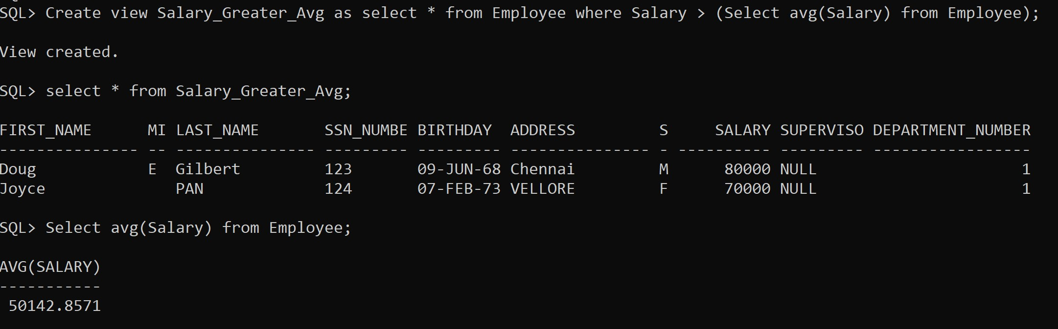

1. **Create a view to display all employees whose salary is lower than all the employees of the department 1.**

# SQL Command:

Create view Salary_Lower_Dep1 as select * from Employee where Salary < (Select min(Salary) from Employee where Department_Number = 1);

Select * from Salary_Lower_Dep1;

# Screenshot:

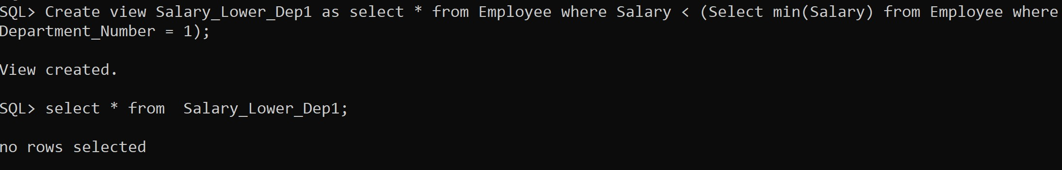

1. **Display all male employees whose salary is greater than the maximum salary of the female employees**

# SQL Command:

Select First_Name, Salary from Employee where Sex = 'M' and salary > (Select max(Salary) from Employee where Sex = 'F');

# Screenshot:

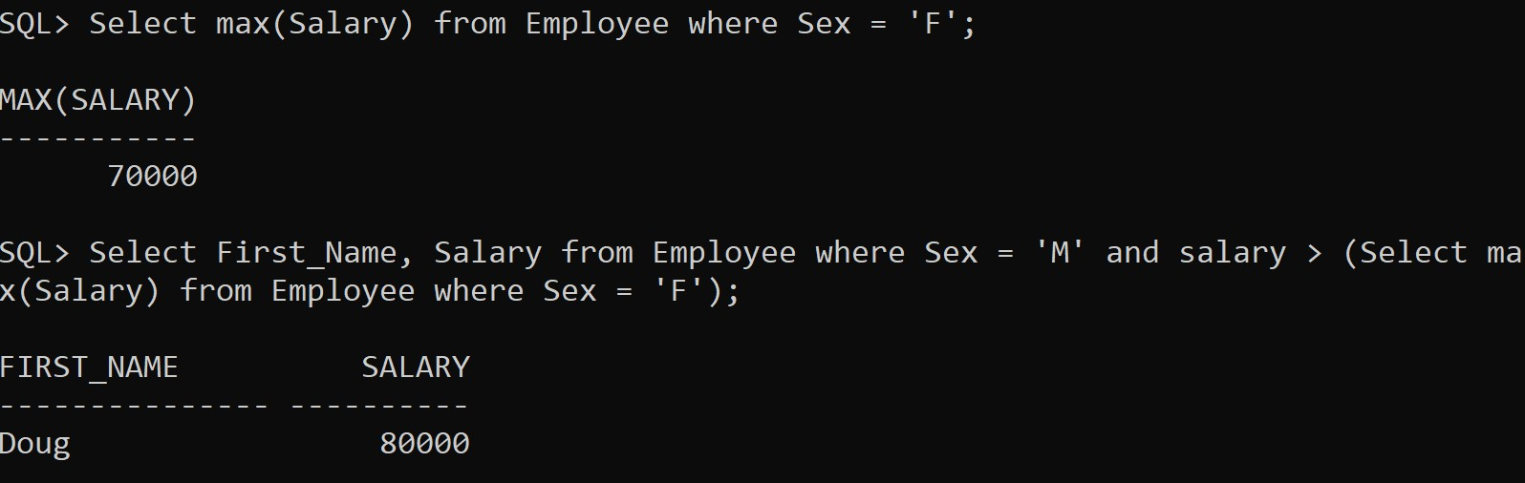

**Aim: To understand how to relate and access data from multiple tables.**

# Consider the schema given in exercise 2, and execute the following queries

1. **Find the names of all the employees who are directly supervised by ‘Joyce’. SQL Command:**

Select * from Employee where Supervisor_SSN = (Select SSN_Number from Employee where First_Name = 'Joyce');

# Screenshot:

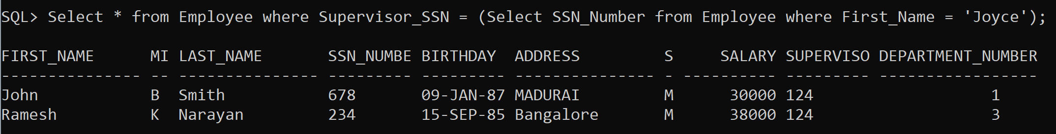

1. **Find the names of all the employees who are working in department ‘Headquarter’.**

# SQL Command:

Select * from (Employee natural join Department) where Department_Name = 'Headquater';

# Screenshot:

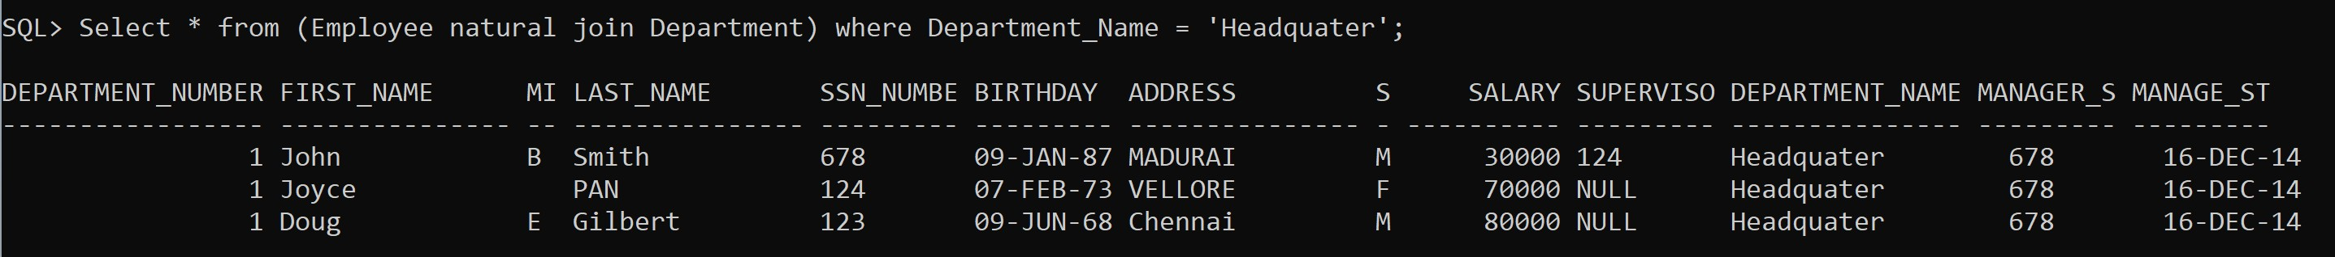

1. **List the department names and if has a manager then display the manager name too.**

# SQL Command:

Select Department_Name, First_Name, SSN_Number from (Department natural join Employee) where Employee.SSN_Number

= Department.Manager_SSN;

# Screenshot:

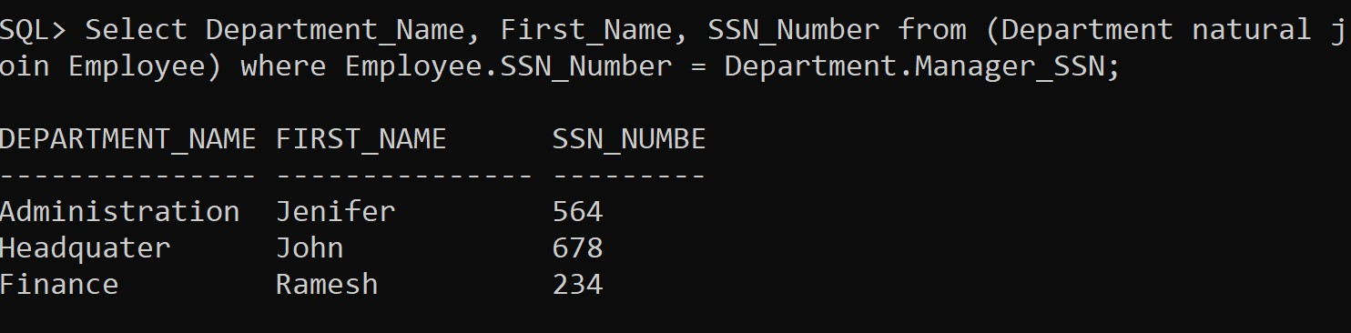

1. **Retrieve the names of the departments which have more than 2 employees. SQL Command:**

Select Department_Name, Department_Number from Department where Department_Number in (Select Department_Number from Employee having count(*) > 2 group by Department_Number);

# Screenshot:

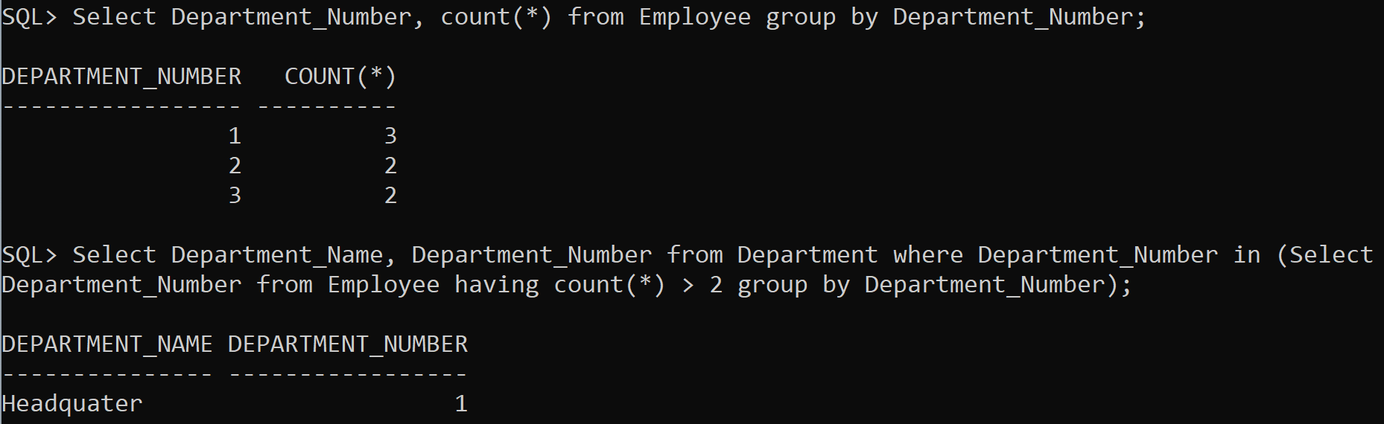

1. **Display the employee name along with the deptname and MgrSSN of that department.**

# SQL Command:

Select First_Name, Department_Name, Manager_SSN from (Employee natural join Department);

# Screenshot:

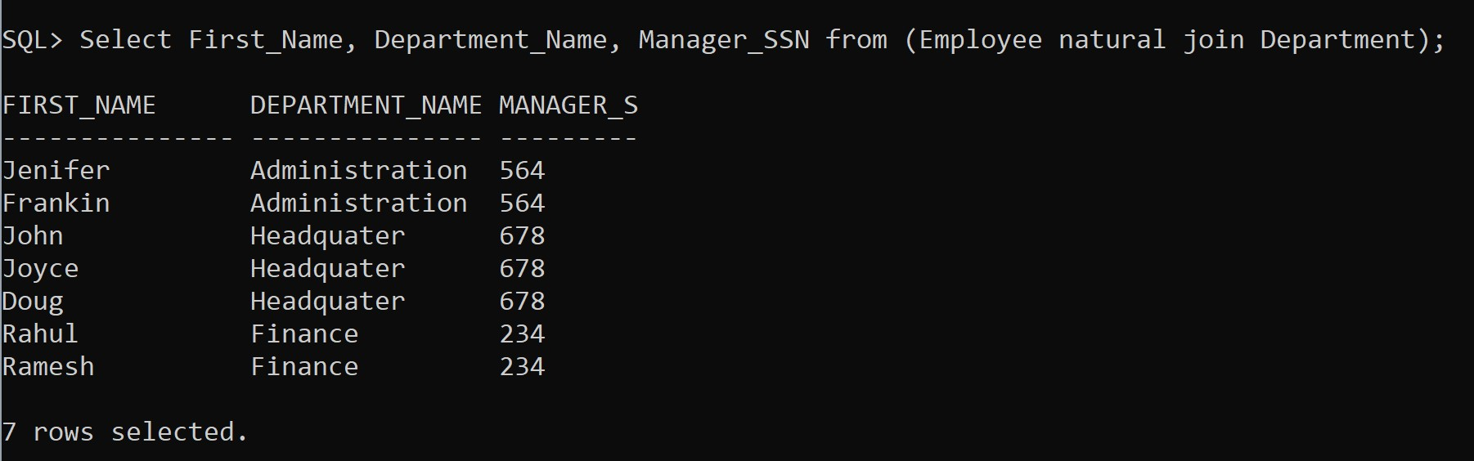

1. **Find out the ename, deptname, deptno, eno of those who are working under some department number (1 or 2 or 3).**

# SQL Command:

Select First_Name, SSN_Number, Department_Name, Department_Number from (Employee natural join Department) where Department_Number = 1;

Select First_Name, SSN_Number, Department_Name, Department_Number from (Employee natural join Department) where Department_Number = 2;

Select First_Name, SSN_Number, Department_Name, Department_Number from (Employee natural join Department) where Department_Number = 3;

# Screenshot:

